What is Executive Functioning?

[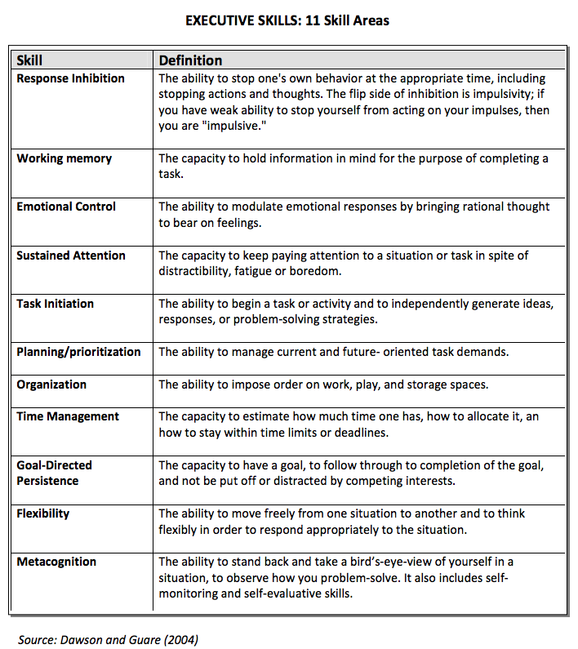](http://mosaiceducation.ca/wp-content/uploads/2012/08/11-Skills.pdf)